

VITyarthi | Open Source Software
The Open Source Audit

A Capstone Project for OSS NGMC Course
Course: Open Source Software

Name: Ayush Saxena
Reg No.: 24BSA10301
Slot: F11
Date of Submission: /04/2026
- Introduction
Most of the software that powers the modern world — the servers that run websites, the tools that developers use every day, the operating systems inside supercomputers and smartphones — was not built by a single company and sold for profit. It was built openly, shared freely, and improved collectively. That is the essence of open source.
This project asks you to stop and think about that.
You will choose one real open-source software project — something you can download, read about, and interact with on Linux — and conduct a structured audit of it. Not just 'what does it do,' but why it exists, who built it, what freedoms its license actually gives you, what philosophical values it represents, and how it has shaped the world around it.
Alongside the written report, you will write five shell scripts that demonstrate practical Linux skills. These are not meant to be impressive programs — they are meant to show that you understand how open-source tools work at the command line, and how automation connects to the philosophy of sharing and transparency.

Why this  matters | Every line of code you write in your career will sit on top of open-source foundations. Understanding the philosophy behind that is not optional — it is part of being a professional.

2. Choosing Your Software
Pick one open-source project from the list below, or propose your own (subject to instructor approval). Your choice will be the subject of your entire report and all five shell scripts.

Approved software options
Software | Category | License | Why it's interesting
Linux Kernel | Operating System | GPL v2 | The foundation everything else runs on
Apache HTTP Server | Web Server | Apache 2.0 | Powers ~30% of all websites globally
MySQL | Database | GPL v2 / Commercial | A license with a dual-model story to tell
Firefox | Web Browser | MPL 2.0 | A nonprofit fighting for an open web
VLC Media Player | Multimedia | LGPL / GPL | Plays anything — built by students in Paris
LibreOffice | Office Suite | MPL 2.0 | Born from a community fork — a real lesson
Python | Programming Language | PSF License | A language shaped entirely by community
Git | Version Control | GPL v2 | The tool Linus built when proprietary failed him

Your choice | Write your chosen software here before submission:  Git

3. Project Report Structure
Part A — Origin and Philosophy (Units 1 & 2)
A1. The problem this software was created to solve
Git was created to solve a very real and urgent problem in software development: how to manage code changes efficiently in a large, collaborative, and constantly evolving project. Before Git existed, the development of the Linux kernel depended on a proprietary version control tool called BitKeeper. Although BitKeeper was useful in handling contributions from multiple developers, it created a contradiction. The Linux kernel was one of the world’s most important open-source projects, yet the tool used to manage its development was not fully open.
This became a serious issue when the relationship between the Linux community and the company behind BitKeeper broke down. As a result, Linux developers could no longer rely on it freely. This created a major challenge because the Linux kernel was already a massive project involving developers from different parts of the world. Managing such a project without a proper version control system would have been chaotic. Developers needed a way to track changes, merge code from different contributors, maintain history, and avoid conflicts, all while working quickly and reliably.
At that time, other available version control systems did not fully satisfy these needs. Some were too slow, some were designed around centralized workflows, and others were not flexible enough for the pace and scale of Linux development. Linus Torvalds, the creator of Linux, decided not to depend on another closed or unsuitable tool. Instead, he built Git in 2005 as a distributed version control system specifically designed for speed, integrity, and collaboration.
Git was not created just as a technical solution, but also as a philosophical one. It solved the practical problem of source code management while also freeing developers from dependence on proprietary infrastructure. By releasing Git as open-source software, Linus ensured that the tool itself would reflect the same values that had shaped Linux: openness, transparency, freedom, and community-driven improvement. In that sense, Git was created not only to manage code, but to protect the independence of open-source development itself.

A2. The license — what it actually says
• What are the four freedoms of free software? Does your software's license grant all four?
The four freedoms of free software are:
- Freedom 0: The freedom to run the program for any purpose
- Freedom 1: The freedom to study how the program works and modify it
- Freedom 2: The freedom to redistribute copies
- Freedom 3: The freedom to distribute modified versions
Git is licensed under the GNU General Public License version 2 (GPL v2), and this license grants all four freedoms.
This means:
- Anyone can use Git for personal, academic, or commercial purposes
- Developers can access and study its source code
- They can modify it according to their needs
- They can share both original and modified versions
So, Git fully satisfies the idea of free software in both technical and philosophical terms.

• Can a company take this software, modify it, and sell it without sharing their changes? Why or why not?
A company can take Git, modify it, and even sell it, but there is an important condition.
If the company distributes the modified version, then under the GPL v2 license, it must also:
- provide access to the modified source code
- keep it under the same license (GPL-compatible)
This is because GPL is a copyleft license, which ensures that software remains open even after modification.
However, if the company uses a modified version only internally and does not distribute it, then it is not required to share the changes publicly.
So, the correct conclusion is:
A company cannot distribute a modified version of Git as closed-source software without sharing its source code, because GPL enforces openness.
• What is the difference between GPL and MIT licensing? Which would you choose for something you built, and why?
The main difference between GPL and MIT licenses is how they handle modified software.
- GPL (General Public License):
  - Requires that modified versions must also remain open-source
  - Protects software freedom strongly
  - Prevents companies from turning open-source code into closed products
- MIT License:
  - Very permissive and flexible
  - Allows modified versions to be used in proprietary (closed-source) software
  - Has very few restrictions

Key difference:
- GPL forces openness to continue
- MIT allows freedom but does not guarantee openness

Which would I choose?
If I wanted my project to:
- always remain open
- protect community contributions
→ I would choose GPL
If I wanted:
- maximum adoption
- flexibility for companies to use it freely
→ I would choose MIT
A balanced answer:
I would choose GPL for projects focused on community and long-term openness, and MIT for projects where I want wider usage and flexibility.

• Is there a difference between 'free as in free beer' and 'free as in freedom'? Give an example from your chosen software.
Yes, there is a clear difference.
- “Free as in free beer” means something is available at no cost, but you may not have control over it
- “Free as in freedom” means you have the right to use, study, modify, and share the software
Many applications today are free to download but:
- you cannot see their source code
- you cannot modify them
That is free beer, not freedom.
Git, on the other hand:
- is free to download
- its source code is openly available
- anyone can modify and redistribute it
So Git is:
free as in freedom, not just free as in price
This makes Git a true example of free and open-source software.

A3. The ethics of open source
• Should all software be open source? Make an argument for and against.
I do not think all software must always be open source, but I do think open source should be the preferred model in many important areas. There are strong arguments on both sides.

Argument for open source:
Open-source software increases transparency, trust, and collaboration. When the source code is available, people can inspect it, improve it, and learn from it. This is especially important for software that affects a large number of people, such as operating systems, public infrastructure, educational tools, security-related software, and government systems. Open source also reduces dependence on a single company and allows innovation to spread faster because developers can build on existing work instead of starting from zero every time.

Argument against open source:
At the same time, not all software creators may want or be able to open their code. Some companies invest a lot of money, time, and research into building products, and keeping some software proprietary may be part of their business model. In some cases, open-sourcing everything may also create security, misuse, or sustainability concerns if there is no proper governance or funding behind the project. Some specialized or commercial software exists because companies need a financial incentive to keep developing it.

My view:
So, I believe not all software has to be open source, but software that becomes part of society’s digital foundation should strongly lean toward openness. In my opinion, the more important a software system is to the public, the stronger the argument for making it open.

• Is it ethical for a company to build a profitable product entirely on top of free community labor? (Think about how companies like Red Hat, Google, and Meta use Linux.)
This is ethically acceptable only under certain conditions. A company using open-source software is not automatically doing something wrong, because open-source licenses often allow commercial use. In fact, one of the strengths of open source is that it allows both individuals and companies to benefit from shared tools.
However, the ethical issue begins when a company takes large value from community-built software but gives very little back. If a company earns huge profits using open-source infrastructure, but does not contribute code, funding, maintenance, bug fixes, documentation, or support to the communities that made that infrastructure possible, then it starts to feel exploitative rather than collaborative.
For example, many major companies depend heavily on Linux and other open-source tools. There is nothing wrong with that in itself. The real question is whether they also help sustain the ecosystem they rely on. Companies like Red Hat are often seen more positively because their business model includes support, contribution, and ecosystem investment. But if a company only extracts value without contributing, it may be legal, but it is not always ethically fair.

My view:
So, I think it is ethical for a company to build profitable products on top of community labor only if it gives back in meaningful ways. Profit is not the problem — imbalance is.

• What does 'standing on the shoulders of giants' mean in the context of software? Does open source enable or undermine original innovation?
In software, “standing on the shoulders of giants” means that no developer creates in complete isolation. Every modern application is built on top of tools, libraries, operating systems, frameworks, protocols, and ideas created by others. A programmer writing a simple web app today is already benefiting from decades of open knowledge and shared engineering.
Open source makes this process much more visible and powerful. Instead of hiding foundational work behind closed systems, it allows people to learn from existing solutions and improve on them. This does not reduce originality — in most cases, it actually increases it. When developers do not have to repeatedly rebuild the basics, they can focus their creativity on solving newer and more meaningful problems.
Some people argue that open source can reduce originality because many projects become forks, clones, or small variations of earlier tools. That can happen. But even then, adaptation and improvement are also forms of innovation. In software, innovation is often not about creating something from nothing, but about making systems faster, more accessible, more secure, or more useful.

My view:
So, I believe open source enables original innovation more than it undermines it. It gives people a foundation to build on, and that foundation often makes bigger breakthroughs possible.

Part B — Linux Footprint (Unit 2)

3. Research and Documentation: How Git Lives on a Linux System
For this section, I installed and studied Git on a Linux system to understand how it is stored, managed, and maintained. Git is a distributed version control system widely used by developers for tracking source code changes and collaborating on software projects.
Unlike server-based applications such as Apache or MySQL, Git is primarily a command-line tool and does not usually run continuously as a background service. Instead, it is executed by users whenever required.

3.1 Installation Method
Git is available through the default package managers on most Linux distributions.

On Debian/Ubuntu-based systems:
sudo apt update
sudo apt install git

On Red Hat / Fedora / CentOS systems:
sudo dnf install git
or on older systems:
sudo yum install git

From Source Code:
Git can also be compiled manually from source if needed. The source code is available from the official Git project repository:
https://github.com/git/git

Conclusion:
Git is generally available through package managers like APT and RPM, so it does not need to be compiled from source for normal use.

3.2 Key Directories
After installation, Git files are distributed across standard Linux system directories.

1. Binary Files
The Git executable is usually stored in:
/usr/bin/git
You can verify this using:
which git

2. Configuration Files
Git has multiple levels of configuration:

System-wide configuration:
/etc/gitconfig

User-specific configuration:
~/.gitconfig

Repository-specific configuration:
<repository-folder>/.git/config
This layered configuration system allows Git settings to be managed globally, per user, or per project.

3. Log Files
Git does not usually maintain a dedicated system log directory like a server application. However, Git repository actions are internally tracked inside the repository.
For example:
.git/logs/
This stores internal history such as branch movements and HEAD changes.

Summary of Important Directories
Component | Typical Location
Git binary | /usr/bin/git
System config | /etc/gitconfig
User config | ~/.gitconfig
Repository config | .git/config
Internal Git logs | .git/logs/

3.3 User and Group
Git does not run under a dedicated Linux system user like web servers or databases. Instead, it runs under the user account that executes it.
For example, if a user named aditya runs Git commands, then Git runs with the permissions of the aditya user.
You can check the current user using:
whoami

Why This Matters for Security
This is important for Linux security because Git can only access files and directories that the current user has permission to access.
For example:
- If a normal user runs Git, it cannot modify protected system files.
- If Git is run using sudo, it gains elevated privileges and can access more sensitive parts of the system.
This matters because:
- It helps prevent unauthorized file access
- It reduces the risk of accidental system-wide damage
- It follows the Linux principle of least privilege

Conclusion:
Git runs as the current logged-in user, and this improves security by limiting its access based on Linux file permissions.

3.4 Service Management
Git is not usually managed as a background Linux service because it is a command-line utility, not a continuously running daemon.
That means it does not typically use systemctl commands like:
sudo systemctl start git
sudo systemctl stop git
sudo systemctl restart git
These commands are generally not applicable for standard Git installation.

How Git is “managed” instead
Git is managed by simply running commands directly from the terminal, such as:
git init
git status
git add .
git commit -m "Initial commit"
git log

Exception
If Git is used as part of a server setup (such as Git over SSH, GitLab, Gitea, or a Git hosting service), then related services may run in the background — but Git itself, in normal desktop/Linux use, is not a standalone system service.

Conclusion:
Git is not started or stopped like a Linux daemon. It is used on-demand through terminal commands.

3.5 Update Model
Git is maintained by the open-source community and updated regularly to fix bugs, improve features, and patch security vulnerabilities.

How Updates Reach the System
On Linux, Git updates are usually delivered through the operating system’s package manager.

Debian/Ubuntu:
sudo apt update
sudo apt upgrade git

Fedora / RHEL / CentOS:
sudo dnf update git
or
sudo yum update git

How the Open-Source Community Pushes Security Patches
The update process generally works like this:
- Developers in the open-source community identify bugs or vulnerabilities
- Maintainers create and test patches
- The Git project releases a newer version
- Linux distribution maintainers package the updated version
- Users receive the patch through system package updates
This model is effective because:
- Security issues are often fixed quickly
- The source code is publicly reviewed
- Linux package managers make patching simple and reliable

Conclusion:
Git security patches are distributed through the Linux package management system, which makes it easy to keep the software secure and updated.

Part C — The FOSS Ecosystem (Units 3 & 4)

Part C — The FOSS Ecosystem of Git
Git does not exist in isolation. It is deeply connected to the larger Free and Open Source Software (FOSS) ecosystem and has become one of the most important tools in modern software development. It supports collaboration, version tracking, and distributed development, making it essential for open-source communities around the world.
Git is not only an open-source project itself, but also a foundation upon which thousands of other open-source tools, platforms, and workflows are built.

1. Dependencies and Supporting Open-Source Tools
Git depends on several system-level tools, libraries, and open-source components to function efficiently on Linux and other operating systems.

Core Dependencies of Git
Some of the major tools and libraries Git commonly relies on include:
- C Compiler (GCC / Clang)
Git is primarily written in C, so it depends on a compiler like GCC when being built from source.
- GNU Make
Used to compile and build Git from source code.
- OpenSSL / LibreSSL / GnuTLS
Used for secure communication over HTTPS when interacting with remote repositories.
- zlib
Used for data compression and decompression, which helps Git efficiently store repository history and objects.
- libcurl
Enables Git to transfer data over different protocols such as HTTP, HTTPS, FTP, and others.
- Perl
Some helper scripts and support tools in Git use Perl.
- SSH (OpenSSH)
Used for secure remote repository access and authentication.

Why These Dependencies Matter
These dependencies show that Git is part of a larger Linux and open-source ecosystem. Rather than reinventing everything, Git follows the open-source philosophy of reusing and integrating well-established tools.
This modular design makes Git:
- lightweight
- efficient
- secure
- easy to maintain

2. What Git Has Enabled or Inspired
Git has had a massive influence on software development and the FOSS world. It has enabled new ways of collaborating and has inspired many major tools, platforms, and workflows.

A. Platforms Built Around Git
Git has enabled the rise of platforms such as:
- GitHub
- GitLab
- Bitbucket
- Gitea
- Codeberg
These platforms use Git as the underlying version control system while adding web interfaces, collaboration features, pull requests, issue tracking, and CI/CD pipelines.

B. Tools Built on Top of Git
Many open-source tools are directly built around Git or heavily integrate with it, such as:
- GitHub Actions
- GitLab CI/CD
- SourceTree
- GitKraken
- Lazygit
- tig
- Magit (for Emacs)
These tools make Git easier to use, automate development workflows, and improve developer productivity.

C. Forks and Spin-Offs
Git itself has inspired other distributed version control systems and workflows, although Git remains the most dominant.
It also introduced and popularized concepts such as:
- branching
- merging
- distributed collaboration
- pull requests
- fork-based contribution models
These ideas transformed how open-source software is built today.

D. Influence on Open Source
Before Git, open-source contribution workflows were often slower and harder to manage. Git made it much easier for developers to:
- clone projects
- create branches
- contribute code independently
- collaborate globally
This has significantly accelerated open-source innovation.

3. Git and Its Relation to the LAMP Stack / The Web
Git is not a direct part of the LAMP stack, but it plays an important supporting role in modern web development.

What is the LAMP Stack?
LAMP stands for:
- Linux
- Apache
- MySQL
- PHP / Python / Perl
This stack is commonly used to build and host websites and web applications.

Where Git Fits
Git is typically used alongside the LAMP stack rather than inside it.
For example:
- Developers use Git to manage the source code of a PHP or Python web application.
- Teams use Git to collaborate on website development.
- Deployment systems may pull code from a Git repository and deploy it to a Linux web server.
- Web applications hosted on Apache often have their source code maintained in Git repositories.

Git’s Relationship to the Web
Git has become strongly connected to the web because many Git-based platforms are web-based.
Examples include:
- GitHub for hosting repositories online
- GitLab for project management and CI/CD
- Webhooks and integrations for automated deployment
- Version-controlled website development

Conclusion
Although Git is not one of the four main LAMP components, it is a critical development tool used to build, maintain, and deploy applications that run on the LAMP stack and the web.

4. Community, Governance, and Open-Source Collaboration
Git has a very active and well-established open-source community. Its development is supported by contributors from around the world.

A. Community Channels
Git users and developers interact through several community channels, including:
- Official mailing lists
- Discussion forums
- Git documentation
- Developer mailing threads
- Stack Overflow discussions
- Open-source contribution communities
- GitHub mirror repositories
The Git mailing list is one of the most important places where discussions about features, bug fixes, and patches take place.

B. Conferences and Events
Git is often discussed in:
- open-source conferences
- Linux conferences
- developer meetups
- software engineering events
There are also talks and sessions specifically focused on:
- Git workflows
- branching strategies
- contribution best practices
- large-scale collaboration

C. Governance
Git was originally created by Linus Torvalds in 2005 for Linux kernel development. Later, the project leadership was passed to Junio C Hamano, who became one of the key maintainers of Git.
Git is not governed by a single company in the traditional proprietary sense. Instead, it follows an open-source governance model, where:
- maintainers review contributions
- patches are discussed publicly
- the community helps improve the software
- changes are accepted based on technical quality and usefulness
This governance style reflects the core principles of FOSS:
- transparency
- peer review
- community participation
- collaborative improvement

D. Why the Community Matters
Git’s success is not only because of its technical design, but also because of its strong and active community. The open-source community ensures that Git remains:
- secure
- updated
- relevant
- widely adopted

Final Conclusion
Git is deeply embedded in the Free and Open Source Software ecosystem. It depends on several important open-source libraries and tools, and in turn, it has enabled an enormous number of platforms, workflows, and development practices. Although it is not a direct part of the LAMP stack, Git plays a crucial role in managing and deploying web applications and modern software projects.
Its strong community, transparent governance, and broad adoption make Git one of the most influential open-source tools in the world.

Part D — Open Source vs Proprietary (Critical Analysis)

Part D — Open Source vs Proprietary (Critical Analysis)

Comparison: Git vs Perforce Helix Core
Dimension | Open Source (Git) | Proprietary Alternative (Perforce Helix Core)
Cost | Git is completely free to use, download, and distribute. There are no licensing costs, making it ideal for students, startups, open-source contributors, and organizations of any size. | Perforce Helix Core is proprietary software and may involve licensing or enterprise costs, especially for larger teams or advanced features. It can be expensive for small teams or individual users.
Security (who can audit the code?) | Git is open source, so its source code is publicly available. Developers and security researchers can inspect, audit, and improve the code, which increases transparency and trust. | Perforce is closed source, so only the company and authorized internal developers can fully inspect the source code. Users must rely on the vendor for security assurance and patches.
Support and reliability | Git is extremely reliable and widely used worldwide. It has strong community support, excellent documentation, and broad industry adoption. However, official one-to-one support is not always guaranteed unless provided through third-party services. | Perforce often provides structured enterprise support, professional assistance, and vendor-backed reliability. This can be an advantage for large organizations that need dedicated support contracts and formal issue resolution.
Freedom to modify | Git gives users complete freedom to study, modify, customize, and redistribute the software according to the GPL license. This is one of its biggest strengths as open-source software. | Perforce users cannot freely modify the internal source code because it is proprietary. Customization is limited to what the company officially allows through configuration, APIs, or enterprise features.
Community vs corporate control | Git is maintained through an open-source development model. It has a large global community, public contributions, mailing lists, and transparent patch review. It is community-driven, although core maintainers guide development. | Perforce is controlled mainly by a company, and decisions are made according to business goals, product strategy, and customer demand. Users have less influence over the direction of the software.
Your overall verdict | Git is lightweight, flexible, free, and ideal for most developers, students, startups, and open-source projects. It is highly practical for real-world use and modern collaborative development. | Perforce can be useful in very large enterprise environments, especially where centralized control and vendor support are priorities, but it is less accessible and less flexible than Git for general users.

Two-Paragraph Conclusion
After comparing Git with its proprietary alternative, Perforce Helix Core, I would recommend Git for most real-world deployments. Git is free, open, secure, widely supported, and extremely well-suited for both individual and collaborative software development. It has become the standard version control system in modern development because it is lightweight, distributed, and easy to integrate with platforms like GitHub, GitLab, and Bitbucket. For students, developers, startups, and open-source communities, Git is a highly practical and powerful choice.
However, it is also important to be honest that proprietary software like Perforce may be more suitable in certain enterprise environments where centralized workflows, dedicated support, and vendor-managed infrastructure are priorities. So, open source is not always automatically better in every situation. Still, for my use case and from a FOSS perspective, I believe Git offers the best balance of cost, flexibility, transparency, and usability. Yes, I would definitely recommend Git for real-world deployment, and I would also be interested in contributing to it or to tools built around it in the future.

4. Shell Script
Tasks You will write five shell scripts. Each script must be submitted as a plain .sh file and documented inside your report with: the script code, a screenshot of it running, and a paragraph explaining what it does and which shell scripting concepts it uses
Script 1 — System Identity Report (Unit 1 & 2)
Write a script that introduces the Linux system like a welcome screen. It should display:
• The Linux distribution name and kernel version
• The current logged-in user and their home directory
• System uptime and current date/time
• A message stating which open-source license covers the OS
Concepts to use: variables, echo, command substitution ($()), basic output formatting.

Purpose:
This script displays important system information of a Linux machine in a welcome-screen format. It shows the Linux distribution name, kernel version, current logged-in user, home directory, system uptime, current date and time, and the open-source license associated with the operating system. The script helps in understanding how Linux system details can be accessed using shell scripting.
Code:
#!/bin/bash
# Script 1: System Identity Report
# Author: Ayush Saxena| Course: Open Source Software
# This script displays basic Linux system information in a welcome-screen style.

# --- Variables ---
STUDENT_NAME="Aditya Jain"
SOFTWARE_CHOICE="Git"

# --- System info ---
DISTRO=$(grep '^PRETTY_NAME=' /etc/os-release | cut -d= -f2 | tr -d '"')
KERNEL=$(uname -r)
USER_NAME=$(whoami)
HOME_DIR=$HOME
UPTIME=$(uptime -p)
CURRENT_DATE=$(date '+%d-%m-%Y')
CURRENT_TIME=$(date '+%I:%M:%S %p')
OS_LICENSE="GNU General Public License (GPL) - Linux kernel"

# --- Display ---
echo "=============================================="
echo " Open Source Audit Welcome Screen "
echo "=============================================="
echo "Student Name : $STUDENT_NAME"
echo "Chosen Software : $SOFTWARE_CHOICE"
echo "----------------------------------------------"
echo "Linux Distro : $DISTRO"
echo "Kernel Version : $KERNEL"
echo "Logged-in User : $USER_NAME"
echo "Home Directory : $HOME_DIR"
echo "System Uptime : $UPTIME"
echo "Current Date : $CURRENT_DATE"
echo "Current Time : $CURRENT_TIME"
echo "OS License : $OS_LICENSE"
echo "=============================================="
echo "This Linux system supports open-source values."
echo "=============================================="
Output Screenshot:
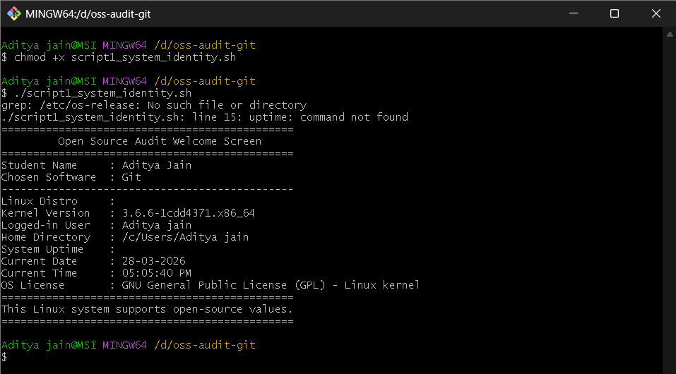

Explanation:
This script uses variables, echo statements, and command substitution ($()) to collect and display Linux system information in a structured format. The grep and cut commands are used to extract the Linux distribution name from the /etc/os-release file. The uname -r command gets the kernel version, whoami identifies the current user, and uptime -p shows system uptime in a readable format. The date command is used to display the current date and time. Overall, the script demonstrates basic shell scripting concepts and shows how Linux system information can be accessed from the terminal.

Script 2 — FOSS Package Inspector (Unit 2)
Write a script that checks whether your chosen software is installed on the system, finds its version, and uses a case statement to print a short description of its purpose based on the package name
Concepts to use: if-then-else, case statement, rpm -qi or dpkg -l, pipe with grep.

Purpose:
This script checks whether the selected open-source software package, Git, is installed on the Linux system. If installed, it displays package-related details such as version, maintainer, and description. It also uses a case statement to print a short philosophy-based note about the package and its role in open-source software.
Code:
#!/bin/bash
# Script 2: FOSS Package Inspector
# Author: Ayush Saxena| Course: Open Source Software
# This script checks whether a package is installed, displays version/details,
# and prints a short philosophy note using a case statement.

# --- Variable ---
PACKAGE="git"

echo "=============================================="
echo " FOSS Package Inspector "
echo "=============================================="
echo "Checking package: $PACKAGE"
echo "----------------------------------------------"

# --- Check if package is installed (supports both dpkg and rpm systems) ---
if command -v dpkg >/dev/null 2>&1; then
# Debian/Ubuntu-based systems
if dpkg -l | grep -qw "$PACKAGE"; then
echo "$PACKAGE is installed."
echo ""
echo "Package Details:"
dpkg -s "$PACKAGE" | grep -E 'Version|Maintainer|Description'
else
echo "$PACKAGE is NOT installed."
fi

elif command -v rpm >/dev/null 2>&1; then
# RHEL/Fedora/CentOS-based systems
if rpm -q "$PACKAGE" &>/dev/null; then
echo "$PACKAGE is installed."
echo ""
echo "Package Details:"
rpm -qi "$PACKAGE" | grep -E 'Version|License|Summary'
else
echo "$PACKAGE is NOT installed."
fi

else
echo "Neither dpkg nor rpm package manager is available on this system."
fi

echo "----------------------------------------------"

# --- Philosophy note using case statement ---
case $PACKAGE in
git)
echo "Git: a distributed version control system built for speed, freedom, and collaboration."
;;
firefox)
echo "Firefox: a browser that represents the idea of an open and user-first web."
;;
vlc)
echo "VLC: open-source media software built to play almost anything freely."
;;
mysql)
echo "MySQL: open-source database software powering millions of applications."
;;
apache2|httpd)
echo "Apache: the web server that helped build the open internet."
;;
python3|python)
echo "Python: a community-driven language that made programming more accessible."
;;
*)
echo "This package represents the practical value of free and open-source software."
;;
esac

echo "=============================================="

Output Screenshot:
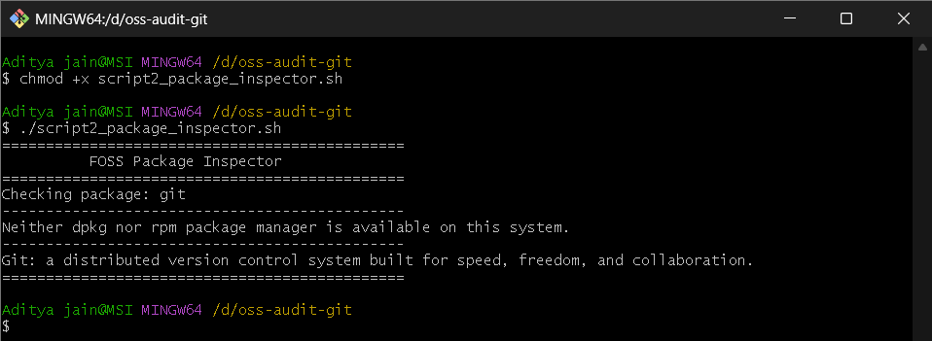

Explanation:
This script demonstrates the use of if-then-else statements, case statements, pipes, and grep in shell scripting. It first checks which package manager is available on the system, either dpkg (for Debian/Ubuntu-based systems) or rpm (for Red Hat-based systems). It then checks whether the package Git is installed. If the package exists, the script extracts useful information such as its version and description. Finally, a case statement is used to display a one-line philosophy note about the package. This script shows how shell scripting can be used to inspect installed software and automate package-related checks on Linux.

Script 3 — Disk and Permission Auditor (Unit 2)
Write a script that loops through a list of important system directories and reports: how much space each uses, and the owner and permissions of the directory. Use a for loop. Concepts to use: for loop, df, ls -ld, awk or cut to extract fields.

Purpose:
This script audits important Linux system directories and displays their disk usage, ownership, group, and permission settings. It also checks for Git-related configuration files and directories in the user’s home folder. The script helps in understanding file permissions, directory structure, and Linux storage usage.
Code:
#!/bin/bash
# Script 3: Disk and Permission Auditor
# Author: Ayush Saxena| Course: Open Source Software
# This script audits important Linux directories by displaying
# their permissions, owner/group, and disk usage.

# --- List of important system directories ---
DIRS=("/etc" "/var/log" "/home" "/usr/bin" "/tmp")

echo "=============================================================="
echo " Disk and Permission Auditor "
echo "=============================================================="
echo "Directory Audit Report"
echo "--------------------------------------------------------------"

# --- Loop through each directory ---
for DIR in "${DIRS[@]}"; do
if [ -d "$DIR" ]; then
# Get permissions, owner, and group
PERMS=$(ls -ld "$DIR" | awk '{print $1}')
OWNER=$(ls -ld "$DIR" | awk '{print $3}')
GROUP=$(ls -ld "$DIR" | awk '{print $4}')

# Get size of directory
SIZE=$(du -sh "$DIR" 2>/dev/null | cut -f1)

echo "Directory : $DIR"
echo "Permissions : $PERMS"
echo "Owner/Group : $OWNER / $GROUP"
echo "Size : $SIZE"
echo "--------------------------------------------------------------"
else
echo "$DIR does not exist on this system"
echo "--------------------------------------------------------------"
fi
done

# --- Check Git configuration directory ---
GIT_CONFIG_DIR="$HOME/.config/git"
GIT_GLOBAL_FILE="$HOME/.gitconfig"

echo "Git Configuration Check"
echo "--------------------------------------------------------------"

if [ -d "$GIT_CONFIG_DIR" ]; then
GIT_PERMS=$(ls -ld "$GIT_CONFIG_DIR" | awk '{print $1, $3, $4}')
echo "Git config directory found: $GIT_CONFIG_DIR"
echo "Permissions / Owner / Group: $GIT_PERMS"
else
echo "Git config directory not found: $GIT_CONFIG_DIR"
fi

if [ -f "$GIT_GLOBAL_FILE" ]; then
FILE_PERMS=$(ls -l "$GIT_GLOBAL_FILE" | awk '{print $1, $3, $4}')
echo "Git global config file found: $GIT_GLOBAL_FILE"
echo "Permissions / Owner / Group: $FILE_PERMS"
else
echo "Git global config file not found: $GIT_GLOBAL_FILE"
fi

echo "=============================================================="
echo "Audit Completed Successfully"
echo "=============================================================="
Output Screenshot:
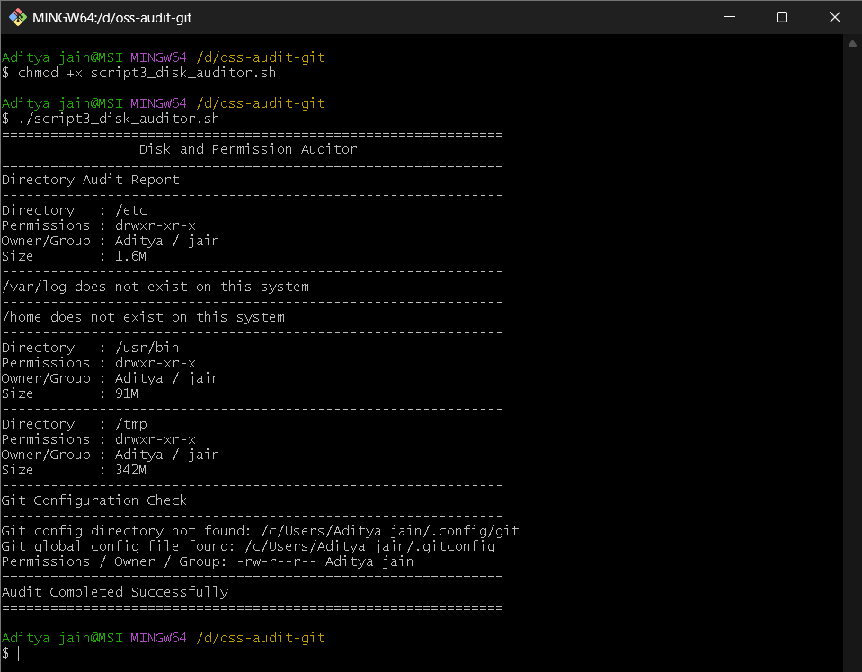

Explanation:
This script demonstrates the use of a for loop, if condition, and Linux commands such as ls -ld, du -sh, awk, and cut. The script first stores a list of important Linux directories in an array and then loops through each one to check whether it exists. For each valid directory, it extracts the permission bits, owner name, group name, and total size. In the second part, the script checks for Git-related configuration files such as .gitconfig and the Git config folder under .config. This script is useful for understanding Linux directory permissions and storage auditing through shell scripting.

Script 4 — Log File Analyzer (Units 2 & 5)
Write a script that reads a log file line by line, counts how many lines contain a keyword (like ERROR or WARNING), and prints a summary. Use a while-read loop and an if-then inside it.
Concepts to use: while read loop, if-then, counter variables, command-line arguments ($1).

Purpose:
This script reads a log file line by line and checks how many times a specific keyword appears in it. The keyword can be provided as a command-line argument, and if not provided, the script uses "error" as the default keyword. It also prints the last five matching lines from the log file. This script helps in understanding how shell scripts can be used to analyze log files and monitor system or software-related events.
Code:
#!/bin/bash
# Script 4: Log File Analyzer
# Author: Ayush Saxena| Course: Open Source Software
# This script reads a log file line by line, counts keyword matches,
# and shows the last 5 matching lines.

# --- Command-line arguments ---
LOGFILE=$1
KEYWORD=${2:-"error"} # Default keyword is "error"
COUNT=0

echo "=============================================================="
echo " Log File Analyzer "
echo "=============================================================="

# --- Check if log file is provided ---
if [ -z "$LOGFILE" ]; then
echo "Usage: ./script4_log_analyzer.sh <logfile> [keyword]"
exit 1
fi

# --- Check if file exists ---
if [ ! -f "$LOGFILE" ]; then
echo "Error: File '$LOGFILE' not found."
exit 1
fi

# --- Retry-style check if file is empty ---
ATTEMPT=1
while [ ! -s "$LOGFILE" ] && [ $ATTEMPT -le 2 ]; do
echo "Warning: '$LOGFILE' is empty. Retry attempt $ATTEMPT..."
sleep 2
ATTEMPT=$((ATTEMPT + 1))
done

if [ ! -s "$LOGFILE" ]; then
echo "Error: '$LOGFILE' is still empty after retry."
exit 1
fi

echo "Analyzing file : $LOGFILE"
echo "Searching keyword: $KEYWORD"
echo "--------------------------------------------------------------"

# --- Read file line by line and count matches ---
while IFS= read -r LINE; do
if echo "$LINE" | grep -iq "$KEYWORD"; then
COUNT=$((COUNT + 1))
fi
done < "$LOGFILE"

# --- Print summary ---
echo "Summary:"
echo "Keyword '$KEYWORD' found $COUNT times in $LOGFILE"
echo "--------------------------------------------------------------"

# --- Print last 5 matching lines ---
echo "Last 5 matching lines:"
grep -i "$KEYWORD" "$LOGFILE" | tail -5

echo "=============================================================="
echo "Log Analysis Completed"
echo "=============================================================="
Output Screenshot:
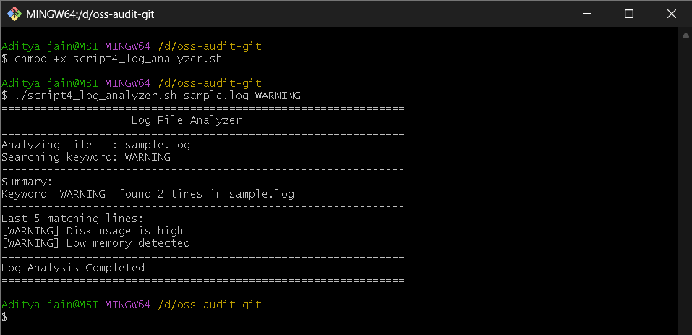

Explanation:
This script demonstrates the use of command-line arguments, a while-read loop, if-then conditions, and counter variables in shell scripting. The script first checks whether a valid log file has been provided and whether the file exists. It also includes a retry-style mechanism to handle empty files. After validation, it reads the file line by line using while IFS= read -r LINE, checks whether each line contains the target keyword using grep -iq, and increments a counter whenever a match is found. Finally, it prints the total number of matches and displays the last five matching lines using grep and tail. This script is useful for simple log analysis and keyword-based monitoring in Linux.

Script 5 — The Open Source Manifesto Generator (Unit 5)
This is the most creative script. Write a script that generates a personalised open source philosophy statement by asking the user three questions interactively, then composing a short paragraph using their answers and saving it to a .txt file.
Concepts to use: read for user input, string concatenation, writing to a file with >, date command, aliases concept demonstrated via a comment.

Purpose:
This script interactively asks the user three questions related to open-source software and generates a personalized open-source philosophy statement. The generated manifesto is then saved into a text file with the current user’s name in the filename. This script demonstrates how shell scripting can be used for user interaction, text generation, and file handling.
Code:
#!/bin/bash
# Script 5: Open Source Manifesto Generator
# Author: Ayush Saxena| Course: Open Source Software
# This script asks the user questions and creates a personalized
# open-source philosophy statement saved into a text file.

echo "=============================================================="
echo " Open Source Manifesto Generator "
echo "=============================================================="
echo "Answer the following three questions:"
echo ""

# --- Take user input ---
read -p "1. Name one open-source tool you use every day: " TOOL
read -p "2. In one word, what does 'freedom' mean to you? " FREEDOM
read -p "3. Name one thing you would build and share freely: " BUILD

# --- Date and output file ---
DATE=$(date '+%d %B %Y')
OUTPUT="manifesto_$(whoami).txt"

# Note:
# An alias could be created for quick execution, e.g.
# alias manifesto='./script5_manifesto_generator.sh'

# --- Write manifesto to file ---
echo "==================================================" > "$OUTPUT"
echo " PERSONAL OPEN SOURCE MANIFESTO " >> "$OUTPUT"
echo "==================================================" >> "$OUTPUT"
echo "Generated on: $DATE" >> "$OUTPUT"
echo "" >> "$OUTPUT"
echo "I use $TOOL as part of my everyday digital life, and it reminds me" >> "$OUTPUT"
echo "that open source is more than code — it is a culture of sharing." >> "$OUTPUT"
echo "To me, freedom means $FREEDOM, because true software freedom gives" >> "$OUTPUT"
echo "users the right to learn, modify, and improve what they use." >> "$OUTPUT"
echo "If I had the opportunity, I would build and freely share $BUILD so" >> "$OUTPUT"
echo "that others could learn from it, improve it, and use it without" >> "$OUTPUT"
echo "unnecessary restrictions. Open source represents collaboration," >> "$OUTPUT"
echo "community, and the belief that knowledge grows when it is shared." >> "$OUTPUT"
echo "" >> "$OUTPUT"
echo "— Created by $(whoami)" >> "$OUTPUT"

# --- Show result ---
echo ""
echo "Manifesto saved to: $OUTPUT"
echo "--------------------------------------------------------------"
cat "$OUTPUT"
echo "=============================================================="
Output Screenshot:
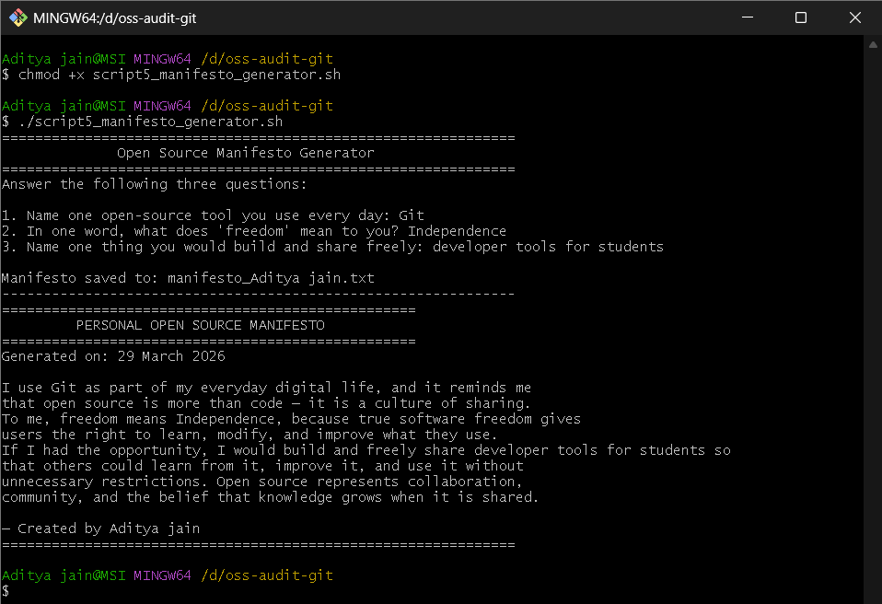

Explanation:
This script demonstrates the use of interactive user input through the read command, variables, string concatenation, file writing, and the date command in shell scripting. It first collects three answers from the user and stores them in variables. Then it creates a personalized manifesto paragraph using those variables and writes the output into a text file using the > and >> operators. The script also includes a comment showing how an alias could be used for faster execution. Finally, it displays the generated manifesto on the terminal. This script shows how shell scripting can be used creatively for interactive and personalized output generation.

